**Analysis of Amplitude Modulated and Demodulated Signal using MATLAB**

**Lab # 08**



**Fall 2023**

**CSE-402L Digital Signal Processing Lab**

Submitted by: **M.SHAHAB**

Registration No.: **21PWCSE207**

Class Section: **C**

“On my honor, as student of University of Engineering and Technology, I have neither given nor received unauthorized assistance on this academic work.”

Submitted to:

**Dr. Yasir Saleem Afridi**

Date:

**26th December 2023**

**Department of Computer Systems Engineering**

**University of Engineering and Technology, Peshawar**

**CSE 402L: Digital Signal Processing**

|  |  |  |  |  |
| --- | --- | --- | --- | --- |
| **Demonstration of Concepts** | **Poor (Does not meet expectation (1))**  The student failed to demonstrate a clear understanding of the assignment concepts | **Fair (Meet Expectation (2-3))**  The student demonstrated a clear understanding of some of the assignment concepts | **Good (Exceeds Expectation (4-5)**  The student demonstrated a clear understanding of the assignment concepts | **Score**  **30%** |
| **Accuracy** | The student completed ( <50%) tasks and provided MATLAB code and/or Simulink models with errors. Outputs shown are not correct in form of graphs (no labels) and/or tables along with incorrect analysis or remarks. | The student completed partial tasks (50% - <90%) with accurate MATLAB code and/or Simulink models. Correct outputs are shown in form of graphs (without labels) and/or tables along with correct analysis or remarks. | The student completed all required tasks (90%-100%) with accurate MATLAB code and/or Simulink models. Correct outputs are shown in form of labeled graphs and/or tables along with correct analysis or remarks. | **30%** |
| **Following Directions** | The student clearly failed to follow the verbal and written instructions to successfully complete the lab | The student failed to follow the some of the verbal and written instructions to successfully complete all requirements of the lab | The student followed the verbal and written instructions to successfully complete requirements of the lab | **20%** |
| **Time Utilization** | The student failed to complete even part of the lab in the allotted amount of time | The student failed to complete the entire lab in the allotted amount of time | The student completed the lab in its entirety in the allotted amount of time | **20%** |

Tasks:

1. Create and plot (both time and frequency domain) a two-tone message signal with amplitude 10v and frequency 300 and 600 Hz

s = 10*sin(2*pi*300*t)+10*sin(2*pi*600*t);

1. Create and plot (both time and frequency domain) the carrier signal with amplitude 10/Modulation Index with frequency of 10 kHz and sampling frequency to 80 kHz. Generate a time vector having a duration of 0.01 s.

m = 0.5

fc = 10e3;

fs = 80e3;

t = (0:1/fs:0.01)';

c = 10/m*sin(2*pi*fc*t)

(Modulation index is a measure of extent of modulation done on a carrier signal. In Amplitude modulation, it is defined as the ratio of the amplitude of modulating signal to that of the carrier signal.)

1. Modulate the message signal with the carrier using the desired Modulation Index. Plot modulated signal in both time and frequency domain. Observe/Analyze the output.
2. Demodulate the Modulated signal. Observe/Analyze the output.

Full Code:

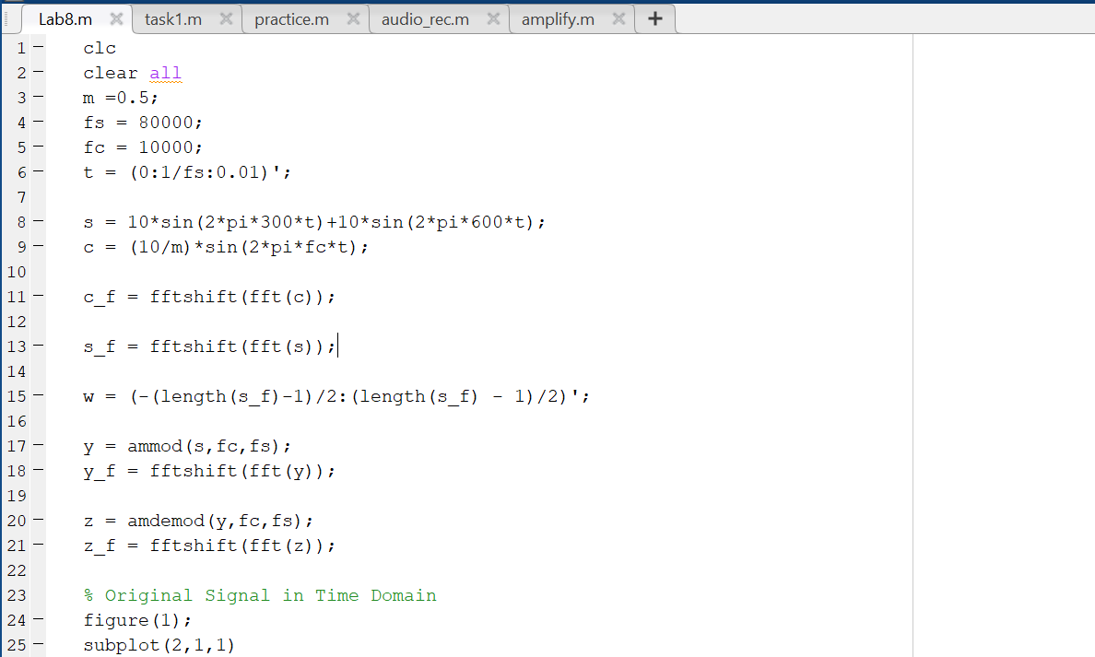

Output:

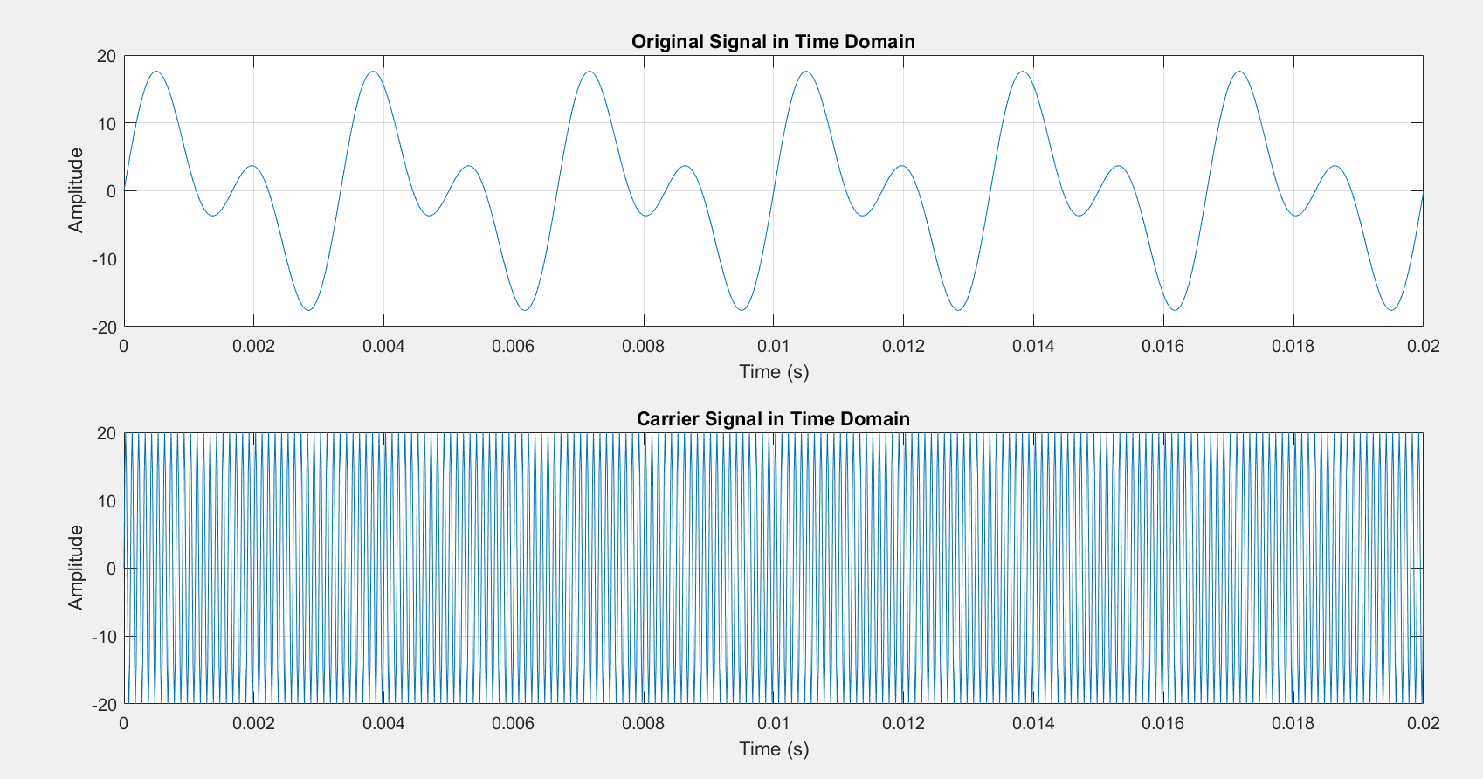

Figure 1

Figure 2

Figure 3

Figure 4

Remarks/Conclusion:

In this lab, I learned how to simulate the process of **Amplitude Modulation (AM)** and **demodulation**. At first, I generated an original signal composed of two sine waves and a carrier signal. I then modulated this signal, creating a modulated signal. This signal was plotted to visualize the modulation effect. Then I also demodulated the signal back to its original form and plot it. Additionally, I analyzed a graph of a modulated signal, noting its properties and the significance of modulation in telecommunications.